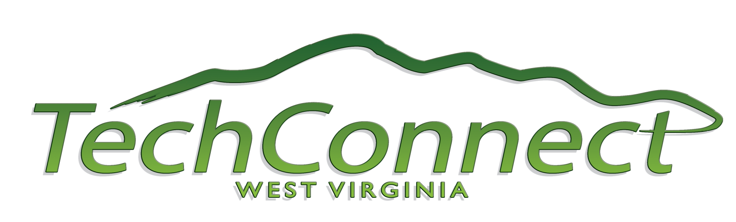

SBIR/STTR/CPP Extended Through May 31, 2011
SBIR/STTR/CPP programs have been extended through May 31, 2011 as a result of a continuing resolution, H.R. 366, passed by both the House and Senate. The President signed it into law on February 3, 2011. Everything stays “as is” during the extension.

TechConnectWV works to enhance awareness, spur collaboration, and raise the discussion of issues surrounding technology-based economic development. Its goals are to diversify the state’s economy, promote economic prosperity, and create high-paying jobs. For more information, contact Anne Barth at 304.444.2918.
###

